**CURRICULUM VITAE**

**Hasan Jasim Hasan**

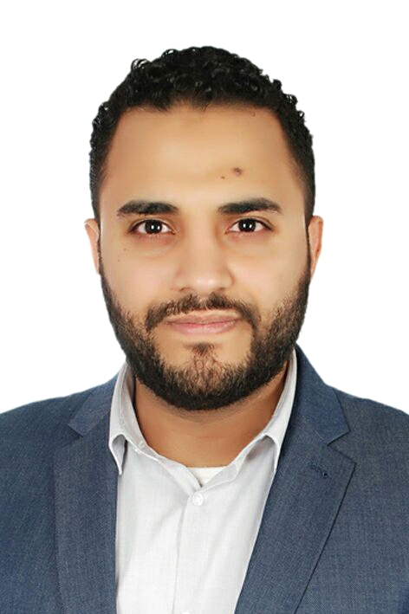

**Summary Profile:**

A dependable, organized with the proven ability to work under pressure without compromising accuracy.

Seeking a position where the organization can benefit from my qualities and provide me with the opportunity to utilize my skills for the benefit of the organization as well as to extend my career objectives.

**Personal Details:**

|  |  |
| --- | --- |
| **Name** | Hasan jasim Ahmed Hasan |
| **CPR NO** | 861106059 |
| **Date of birth** | 4 Nov 1986 |
| **Nationality** | Bahraini |
| **Martial Status** | Married |
| **Address** | VILLA 3471, ROAD 555, H.Town 1205 |
| **Mobile** | +973 38076438 |
| **E-mail** | d2d2d4@live.com |

**Educational & Qualification:**

**. Diploma in Computer Engineering** - 2011 january, College of information Technology, AMA International University Bahrain.

**. The Diploma in Professional Marketing** - 2005 August, Bridge Training Solutions.

**Experience:**

**MOI** – Ministry of Interior

**Rank: (Police officer) Areef**

April 2004 - Bahrain

Job Description:

* Worked at General Directorate of Nationality, Passports and Residenceto 2017.
* Security manager.
* Receptionist/Office Manager.
* Human resource Management

**Hotel** –Park Regis Lotus Hotel

**Public relations officer and Social Media Manager**

April 2018 - Bahrain

Job Description:

* I have Experience in dealing with all ministries and I thorough knowledge of the local laws.
* Develop and manage digital marketing campaigns.
* Oversee a social media strategy.
* Manage and maintain the organisation’s website(s).
* Write and optimise content for the website and social networking accounts such as Facebook, Twitter, Snapchat, Instagram, etc.
* Track and analyse website traffic flow and provide regular internal reports.
* Attain key performance indicators such as reducing the website bounce rate, increasing dwell time or improving conversion.
* Continually work on the Search Engine Optimization of the website(s).
* Fix any errors or bugs in online content.
* Edit and post videos, podcasts and audio content to online sites.
* Arrange webinars and webcasts.
* Create online banner adverts and oversee pay per click (PPC) ad management.
* Write copy for email marketing campaigns.
* Identify new trends in digital marketing, evaluate new technologies and ensure the brand is at the forefront of industry developments, particularly developments in mobile marketing.
* Work on printed material to supplement online products.
* Attend product launches and networking events.

**KAZ** – KAZAAZ

**Social Media Manager**

April 2006 - Bahrain

Job Description:

* **Social media** - Depending on your goals, I create highly targeted social ads to grow your audience, boost brand visibility, improve engagement.
* **YouTube Advertise** - Deliver your message to the right people at the right time with video ads. Every business has an audience on YouTube.
* **SMS Advertise -** Send notifications, advertise and alert with your fully featured Bulk SMS Database & delivery report.
* **Website** - I follow the latest technologies and creative concepts for user-friendly websites. Its not just a website I develop.
* **Email Ads -** Send newsletter, advertise and alert with your fully featured Bulk Email Database & delivery report.
* **Banner -** Publishing your advertise or promotion banners on different high quality websites over targeted place.
* **Google Ads -** Target your ads to customers in certain countries, regions or cities – or within a set distance from your business or shop through Google Network.

**Technical and Softs Skills:**

My graduate studies have eguipped me with a range of specialized technical skills including a range of network and hardware design skills, fundamentals of design techniques, knowledge of production processes. I'm also equipped with soft skills. I have enlisted both here bellow:

* Microsoft Office: MS Word, Excel, powerPoint, Access & Visio.
* Web Developing as creating websites etc...
* Internet Applications and Research.
* Have sound knowledge in networking protocols and device programming.
* PCs Maintenance and Troubleshooting.
* Programing languages: ( Visual Basic - PHP - C language - Java - Matlab C++ - HTML - JavaScript - Ajax - VHDL - Assembly Language).
* Database ( MYSQL "Oracle"- Asccess).
* Design (UML).
* Operating Systems (Windows "XP, vista, 7, 8 - Linux - Unix).
* I am fluent in Arabic and English written and spoken.
* I have effective communication & interpersonal skills.
* Leadership and ability to delegate.
* Good time management skills.
* Ability to word independently and under pressure.
* Excellent in team building.

**Here is a Summary of My Digital Marketing Experience:**

Implementation & fulfillment of Internet Marketing campaigns, encompassing:

* Search Engine Management
* Search Engine Optimization
* Social Media Management
* Reputation Monitoring
* Content Development & Management
* Strategy Documentation
* Website Audit Analysis
* Keyword/phrase Research
* Universal Internet Search
* Geo-Local Targeting
* Market Research
* Brand Management

**Summary of Qualifications**

* CRM Proficient
* Time Management
* Project Management
* Account Management
* Agile Methodology
* Results Driven
* Negotiation Skills
* Relationship Builder
* Problem Solver
* Skilled Analysis & Analytics
* Self-Motivated
* Cold Calling/Prospecting
* Team Player & Leader
* Customer Service Skills
* Adaptability & Flexibility
* Direct Marketing
* Digital Marketing
* Data Driven Strategist

I have a strong experience in digital marketing, I am interested in applying an analytical approach to find answers where strong, creative recommendations can be put in place to adapt and grow a brand, developing into a strong, successful campaign.

Always willing to improve myself in digital marketing, enjoy following recent researches and to keep up to date with the industry, adding a creative and enthusiastic touch to help both the client and the customer achieve their ultimate goals.